Lesson Plan Designed by: Zachariah Ballard

IDAHO magazine article: June 2007; "Idaho Public Parks: Urban Wild,” by Steve Anderson, Bill Corbett and Margo Aragon.

Standard: Idaho State Standard for geography goal 2.4

Theme: Idaho Public Parks (Why the are important and how the effect our everyday life)

Skill: Locating. Analyzing (the importance of public parks)

Gaining Attention: Students will write a list of there three favorite activities and three Idaho landmarks/places that stick out in their heads.

Informing the Learner of the Objective: While working in pairs, students will be able to locate selected Idaho public parks on a map and analyze how public parks contribute to lifestyle and culture. Students will also be able to find out how the parks got there names by using the magazine and researching the internet.

Stimulating Recall of Prerequisite Learning: We have studied the developing of cities in Idaho and will review how the development has effected recreation and wildlife. And now we will consider the effort to conserve wildlife and outdoor recreation through public parks and why it is so important to our everyday lives.

Presenting the Stimulus Material: Pictures displaying the beauty of the parks (via PowerPoint). A map where students will locate the parks with a dot and the name of the park. The map is attached

Eliciting the Desired Behavior: Students will locate parks on a map and on the other side of the page they will explain why and how it got its name by researching it on the internet (http://parksandrecreation.idaho.gov/parks/index.aspx and http://www.cityofboise.org/parks/Parks_facilities/parks/index.aspx?id=parks_listing) and using the article found in Idaho magazine.

Providing Feedback: Students will participate in a discussion about the parks and describe the parks they have been to and why they are so important. (For students who have not been to parks I will ask them to determine where they participate in recreational activities and why those places are so important to them).

Assessing the Behavior: Maps and the information they filled in on the back of the map regarding the history of the parks will be graded and returned the next day.

Closure: Students must list three issues involved with public parks (Land use, entry fees, and privacy laws). This leads into another lecture.

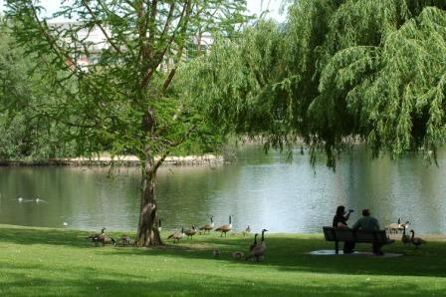
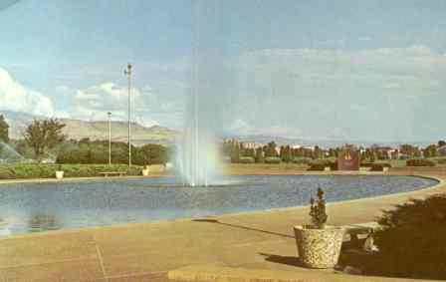

Julia Davis Park
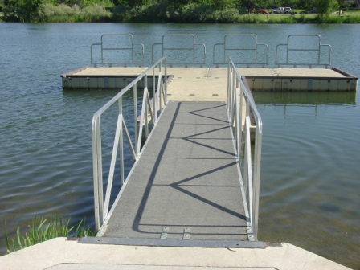
Ann Morrison Park

Parkcenter Park

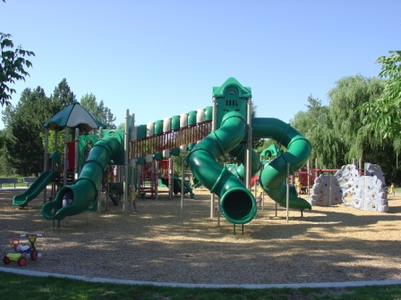

Veterans Memorial Park

